Diccionarios en linea

Go to Google Translate at translate.google.com

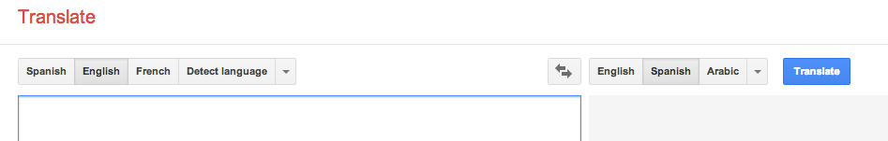In the box on the left, type:

When you have homework you should turn it in on the day it is due.

Make sure the box on the right is set to “Spanish.”

3. Copy down the Spanish translation:

________________________________________________________________________ ________________________________________________________________________
Now click the button between the two boxes that looks like this:

Type the Spanish translation you wrote down into the box on the left. Make sure you are translating English to Spanish now.

Write down the English translation:

________________________________________________________________________ ________________________________________________________________________

What do you notice about this translation?
________________________________________________________________________

Now think of two sentences of your own and try this process again. Try to be creative with your sentences!

- Translate the sentence from English to Spanish
- Translate the Spanish translation back into English

Sentence 1: English
________________________________________________________________________
Spanish translation:
________________________________________________________________________
English translation:
________________________________________________________________________

Sentence 2: English
________________________________________________________________________Spanish translation:
________________________________________________________________________
English translation:
________________________________________________________________________

What do you notice about these translations?
_______________________________________________________________________ _______________________________________________________________________

Now repeat this process with 3 words. Translate only one word at a time. You may choose any word you are interested in.

Word 1: English: ___________________
Spanish translation: _________________
English translation: __________________

Word 2: English: _________________
Spanish translation: _______________
English translation: ________________

Word 3: English: _________________
Spanish translation: _______________
English translation: ________________

What do you notice about these translations?
________________________________________________________________________ ________________________________________________________________________
________________________________________________________________________

In your own words, what is the best way to use an online dictionary like google translate?
________________________________________________________________________
________________________________________________________________________
________________________________________________________________________

